Swachha Bharat PakhWAra-2018
16 December – 31 December
ICAR-Central Inland Fisheries Research Institute, Barrackpore, Kolkata

Institute: ICAR-Central Inland Fisheries Research Institute
Day: 22.12.18
Activity: Presentation and discussion on “Recycling of Waste Water” coordinated by Dr. Srikanta Samanta, Principal Scientist, ICAR-CIFRI, Barrackpore

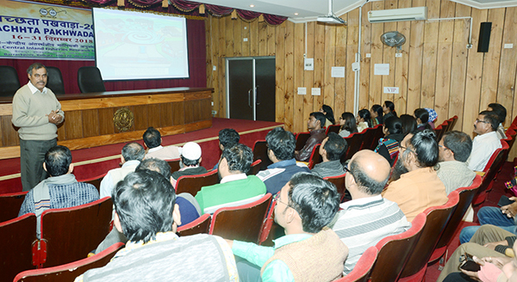
On the occasion of Swachh Bharat Pakhawda a programme was arranged in the auditorium of ICAR-CIFRI, Barrackpore at 3 pm. The programme was coordinated by Dr. Srikanta Samanta, Principal Scientist, ICAR-CIFRI who gave a presentation on “Recycling of Waste Water”. He described the need for water saving, procedure and steps of recycling water, community efforts for water recycling etc. He also explained the principle of 3R, i.e., Reduce-Recycle-Reuse for sustainable water management for future. The presentation was followed by a group discussion among the CIFRI staff members about various aspects of sustainable use of water.

